**Federated Averaging**

**20 client – 8 client**

|  |  |  |  |  |  |  |  |  |  |  |  |
| --- | --- | --- | --- | --- | --- | --- | --- | --- | --- | --- | --- |
|  | %non-iid = 0 | 10 | 20 | 30 | 40 | 50 | 60 | 70 | 80 | 90 | 100 |
| Acc | 0.9914 | 0.9912 | 0.9913 | 0.9909 | 0.991 |  |  |  |  |  |  |
| Precision | 0.9914 | 0.9912 | 0.9913 | 0.9909 | 0.991 |  |  |  |  |  |  |
| Recall | 0.9914 | 0.9912 | 0.9913 | 0.9909 | 0.991 |  |  |  |  |  |  |
| F1-Score | 0.9914 | 0.9912 | 0.9913 | 0.9909 | 0.991 |  |  |  |  |  |  |

**Huấn luyện theo alpha**

**Alpha = 50**

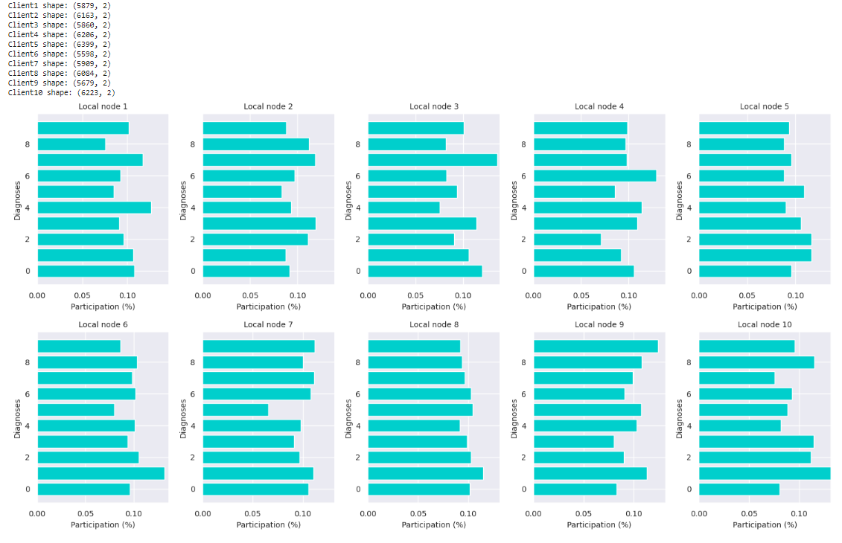

Test: commun_round: 50 | global_acc: 0.9913 | global_pre: 0.9913140209849364 | global_rec: 0.9913 | global_f1s: 0.9913027980822214

'accuracy': [(0, 0.1158), (1, 0.9491), (2, 0.9696), (3, 0.9765), (4, 0.98), (5, 0.9827), (6, 0.9838), (7, 0.9846), (8, 0.9863), (9, 0.9861), (10, 0.9871), (11, 0.9871), (12, 0.9879), (13, 0.9883), (14, 0.9875), (15, 0.9884), (16, 0.9895), (17, 0.9889), (18, 0.9898), (19, 0.9887), (20, 0.9899), (21, 0.9896), (22, 0.9897), (23, 0.9901), (24, 0.989), (25, 0.9901), (26, 0.9901), (27, 0.9897), (28, 0.9893), (29, 0.9905), (30, 0.9899), (31, 0.9896), (32, 0.9895), (33, 0.9907), (34, 0.99), (35, 0.9903), (36, 0.991), (37, 0.99), (38, 0.9913), (39, 0.9905), (40, 0.9897), (41, 0.9905), (42, 0.9897), (43, 0.9907), (44, 0.9905), (45, 0.9899), (46, 0.9902), (47, 0.9906), (48, 0.9895), (49, 0.9901), (50, 0.9906)]